Training Report on Strategic Support for Accreditation of Programs (SSAPI)

The second International Training and Project Meeting of the European Union Erasmus+ Capacity Building in Higher Education (CBHE) project SSAPI (Strategic Support for Accreditation of Programs and Internationalization at South Asian Higher Education Institutes, Project) was attended by a delegation of three representatives from Khesar Gyalpo University of Medical Sciences of Bhutan. The training was held at the University of Évora, Évora, Portugal.
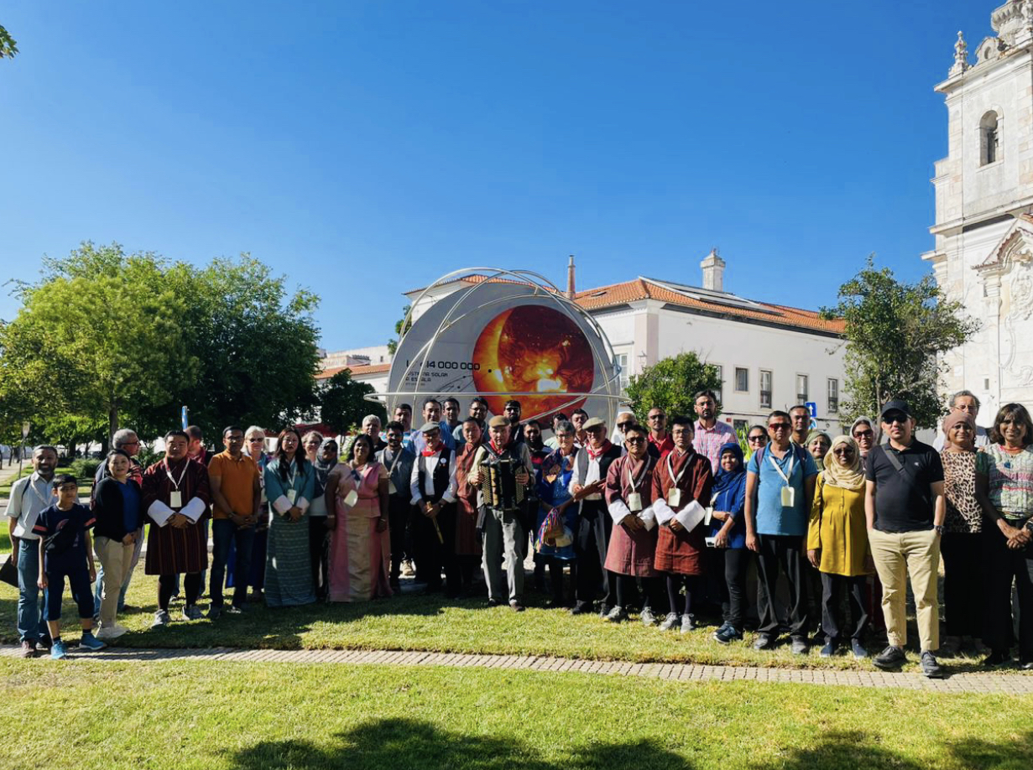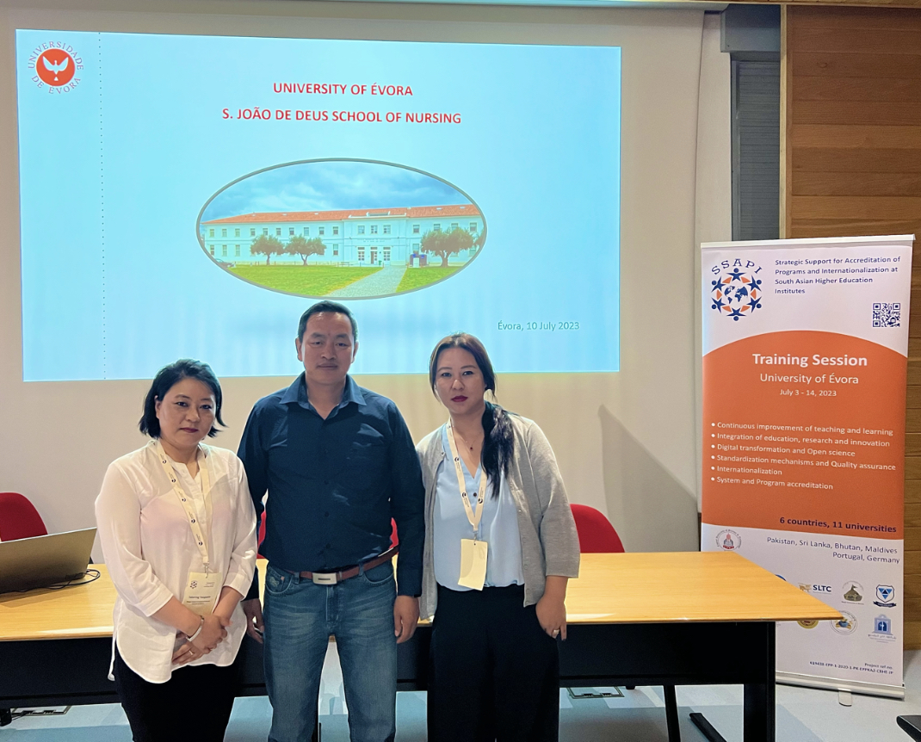
Other universities who joined the consortium came from Royal University of Bhutan, three Universities from Pakistan, two universities each Maldives and Sri Lanka, and one University each from Portugal and Germany.
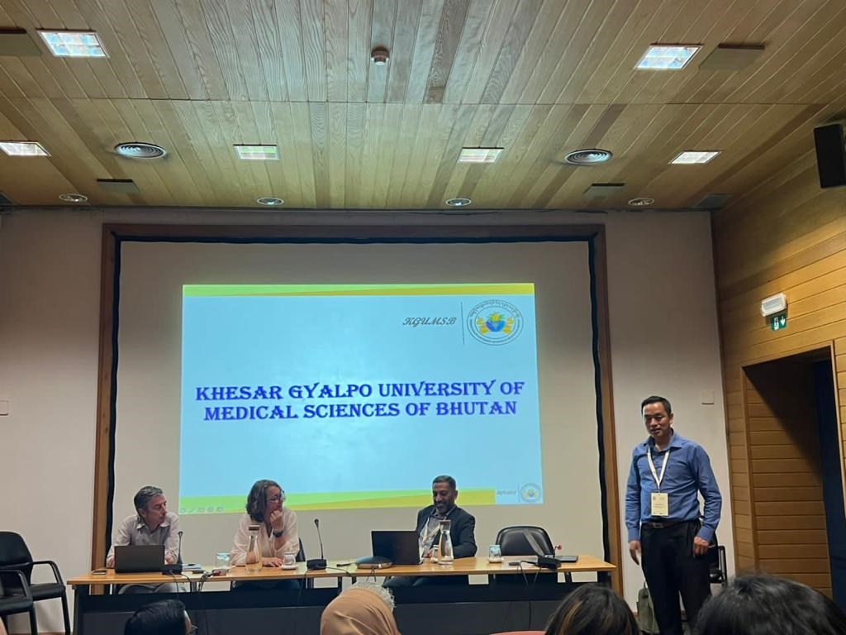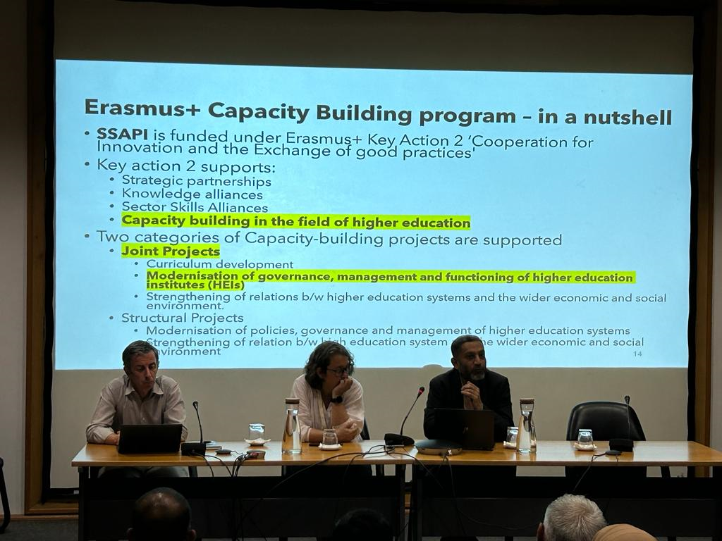
The two-week training was planned and hosted by SSAPI's European partner, the University of Évora from 3rd to 14th July 2023. The program's primary goals were to familiarize participants with the University of Evora’s accreditation procedure and train pertinent partners on the international program accreditation system, internationalization and quality assurance.

Training Program
The two-week program combined project meetings, internationalizations, teaching and learning resource introductions, simulations on program accreditation, and teaching and evaluation procedures.

- Teaching and Learning Resources

The training began with presentations on the engineering, psychology, and nursing programs, followed by a tour of the main Evora campus.

Among the subjects addressed in the training were:
- Earth, a dynamic planet
- Anticline marble quarry
- Research, innovation and internationalization
- Mental Health
- Experiences in Evaluation: the good, the bad and the ugly
- Digital Transformation and Open Science
- Pedagogic Innovation

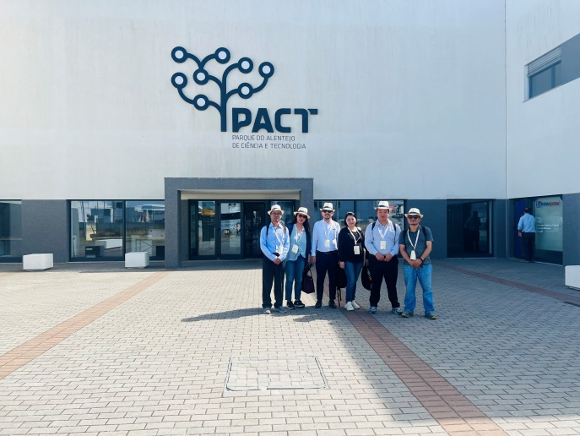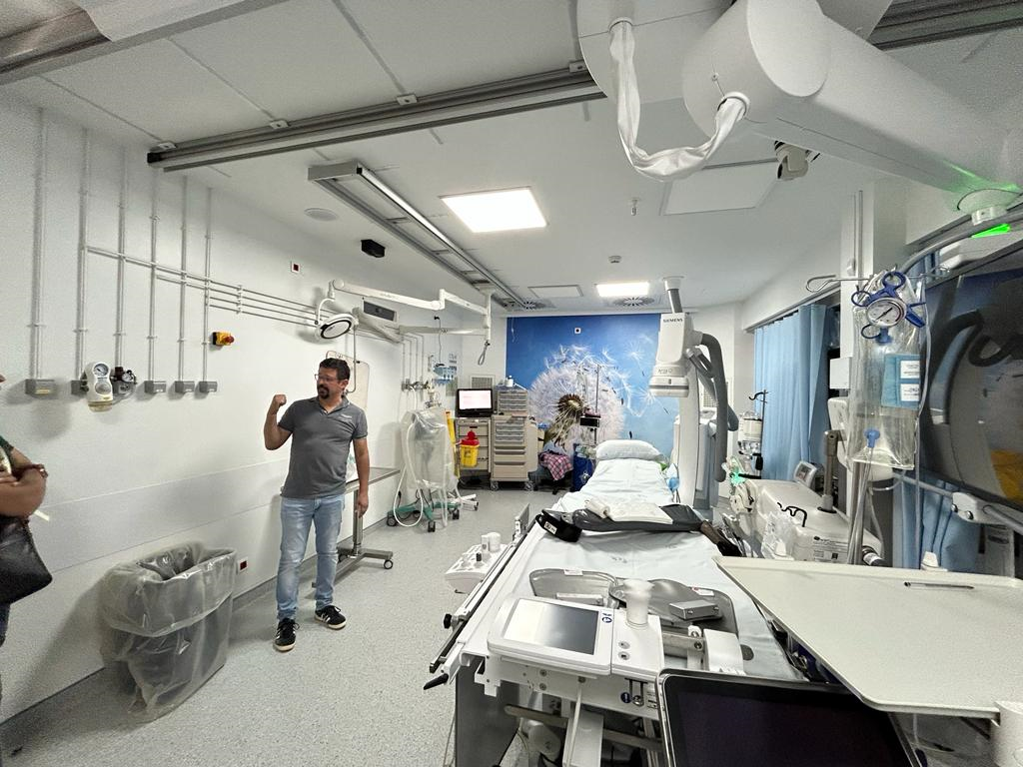
PACT visit Hospital Visit

- Program Accreditation Simulations

As part of the training, the participants had eye-opening tours of the PACT, nursing school, hospital, and psychology lab. The field visit was expanded to include the Medronho Museum in Monsaraz, the Anticline Marble Quarry, the Photovoltaic Plant, the Hydro-Meteorological Platform, and the Unique City Tour.
All participants also embraced the chance to practice and demonstrate during a basic life support session.

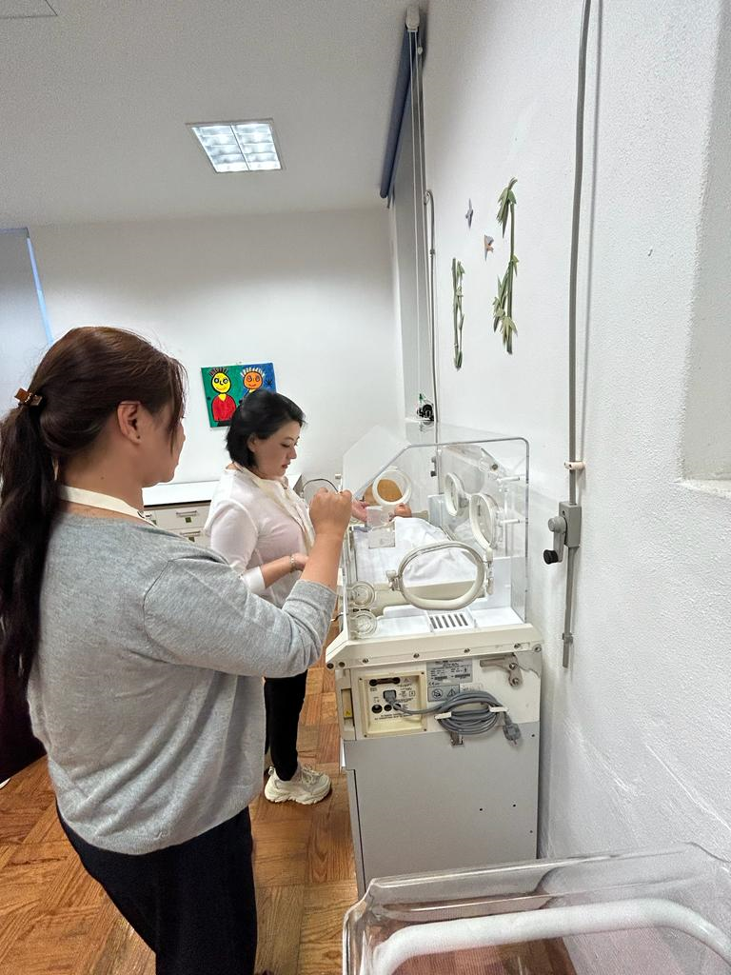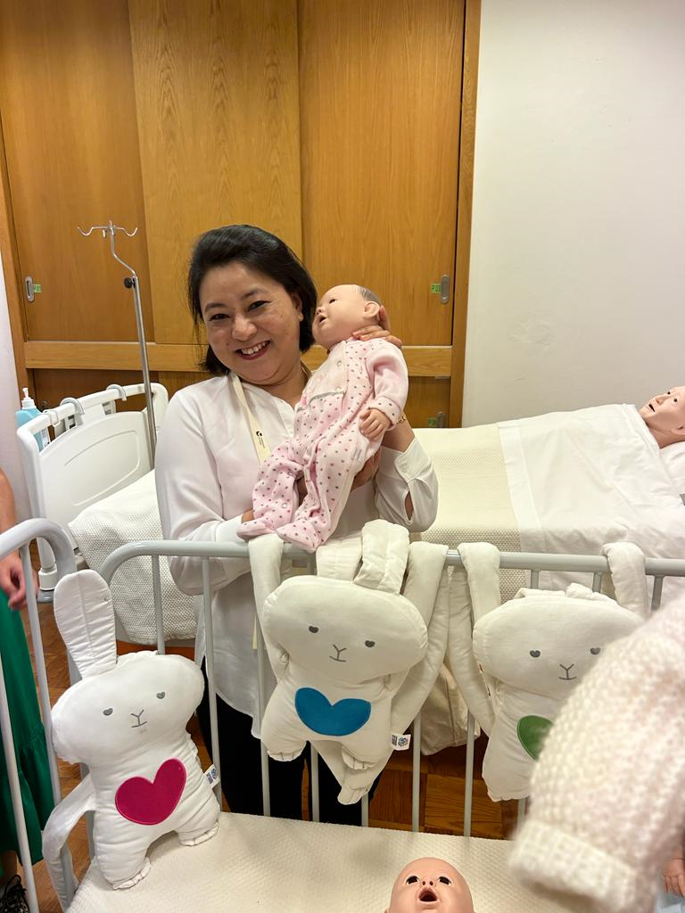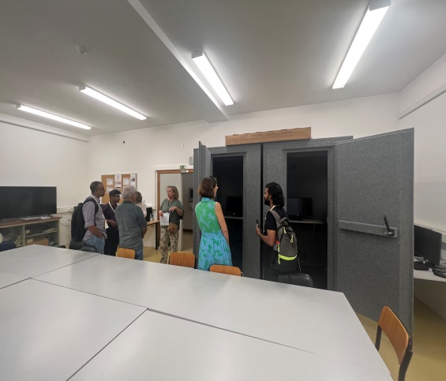
Nursing Lab Psychology Lab

- Familiarization on Teaching Methods and Evaluation Process.

The University of Evora's assessment procedure and teaching strategies were also explained to the participants. The students' presentations and the evaluation procedure were observed by the participants.

- Project Meetings

The project meetings included the Project Managers Meeting and the Project Quality Board meeting on quality control and accreditation, with other members focusing on networking and potential joint ventures.

