ERASMUS+ SSAPI Sri Lanka Workshop: **Project Meeting Report on Project Progress Review** **Strategic Support for Accreditation of Programs and Internalization at South Asian Higher Education Institutes (SSAPI) 2nd- 5th Dec 2023:**

**1. Brief background of the project:**

The “Strategic Support for Accreditation of Programmes and Internationalization at South Asian Higher Education Institutes (SSAPI)” is the Capacity Building Higher Education (CBHE) project of the Erasmus+ Programme funded by the European Union.

The project was awarded in 2020, for a duration of 3 years from 14th January 2021 to 14th January 2024. The project awarded through an open competitive-based grant is implemented by the consortium of 11 partner institutions led by Capital University of Science & Technology, Pakistan. The other ten Higher Education Institutions(HEIs) partners include two from programme countries of the European Union (University of Bremen, Germany and University of Evora, Portugal) and the rest from Asian Countries namely the National University of Computer and Emerging Sciences and Riphah International University from Pakistan, Maldives National University and Villa College from Maldives, University of Peradeniya and Sri Lanka Technological Campus from Sri Lanka and Faculty of Nursing and Public Health, Khesar Gyalpo University of Medical Sciences of Bhutan(KGUMSB) and College of Science & Technology, Royal University of Bhutan(RUB).

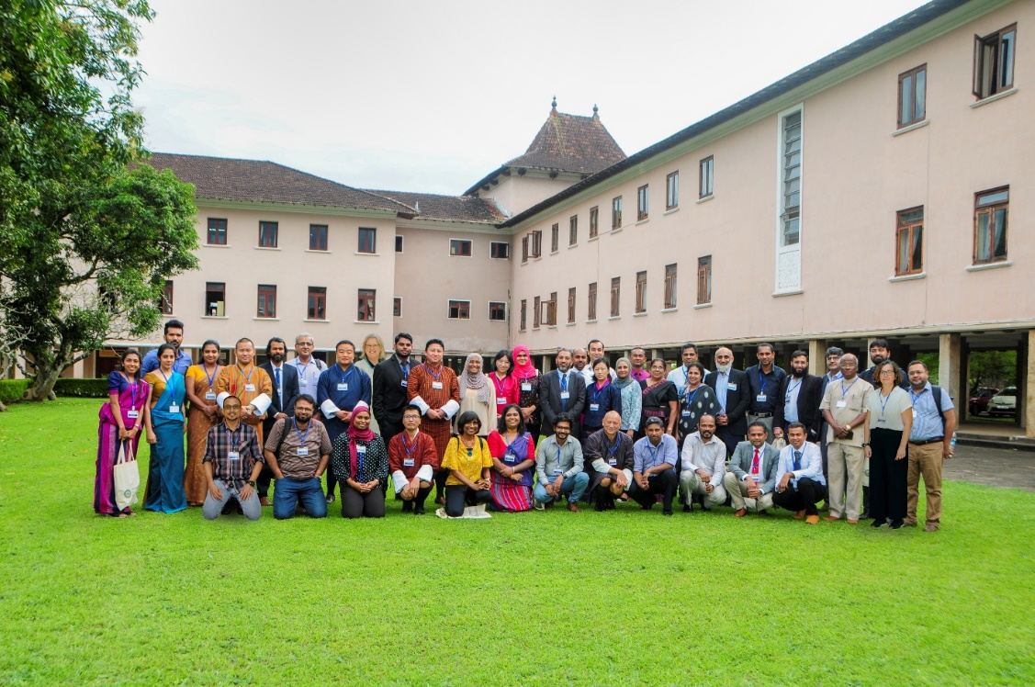

Figure Participants from various member countries

2. ERASMUS+ SSAPI Sri Lanka Workshop and Project Progress Review Meeting:

A four-member delegation from Khesar Gyalpo University of Medical Sciences of Bhutan (KGUMSB) attended the ERASMUS+ SSAPI Sri Lanka Workshop and Project Progress Review Meeting in Sri Lanka organized by University of Peradeniya and Sri Lanka Technological Campus from 2-5th December 2023.

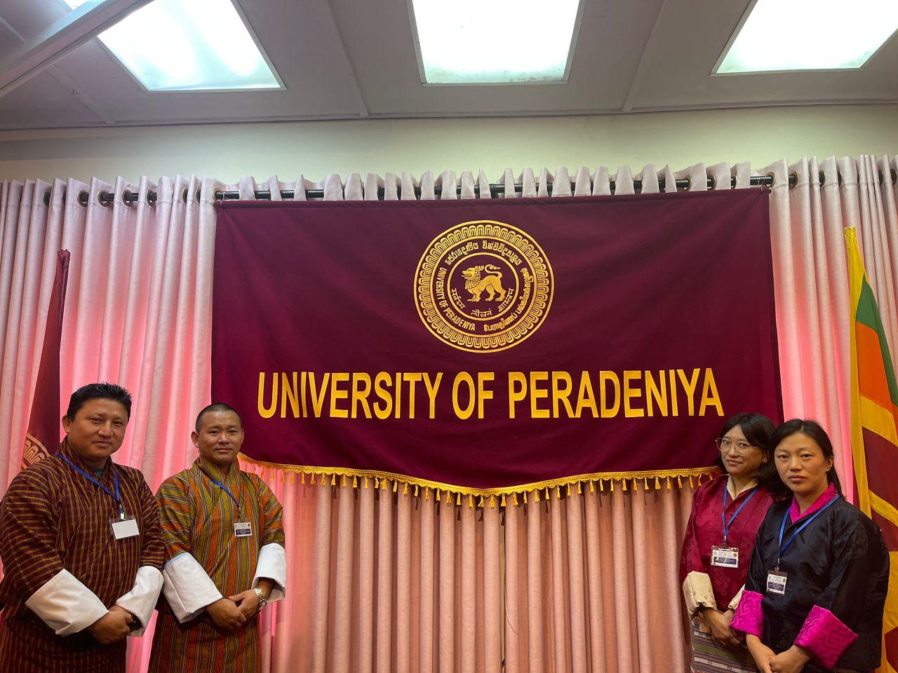

Figure Delegates from Faculty of Nursing and Public Health, KGUMSB

The meeting was to mainly review the progress of the task assigned during the training at University of Evora, Portugal, held from 1st- 16th July 2023. Each Asian universities had to make 10 minutes presentation of project progression followed by a Q& A sessions. The presentation on the progress of the project were reviewed by Ingrid Rugge and Teresa Goncalves, members from programme countries of the European Union – Bremen University, Germany and University of Evora, Portugal respectively.

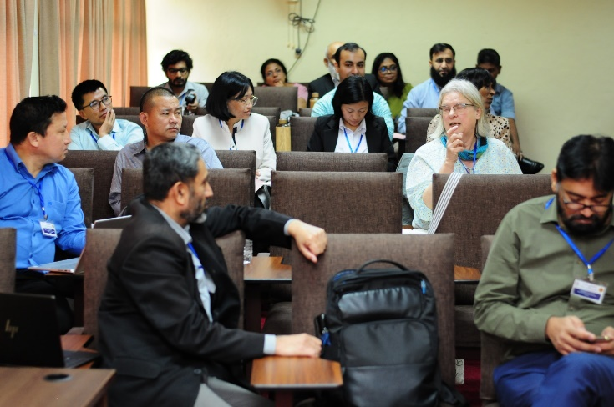 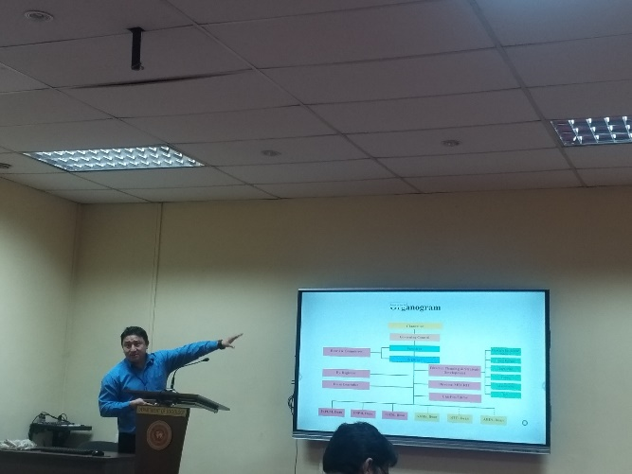

Figure Presentation and Q& A session Figure Project review meeting in progress

**The main objectives of the meeting:**

1. Review the Project Progress
2. Progress of EU trainings and future plans
3. Discuss on new Project Proposal

Besides, the general meetings on project progression, sharing experiences and guided educational tours, the Project managers meeting, Steering Committee Meeting, Dissemination and Publicity Committee Quality Board Meeting and Finance Managers meeting were conducted in parallel sessions.

**Outcomes of the Meeting:**

1. Reviewed the progress of project.
2. Exchange of best practices for accreditation and internationalization through knowledge sharing of the partner Universities.
3. Discussed and agreed on exploring new collaborative projects by partners.
4. Upcoming project meeting and trainings in Bhutan finalized (first – second week of March 2024).