**

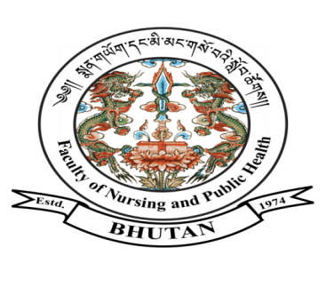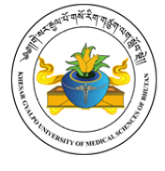

***FACULTY OF NURSING AND PUBLIC HEALTH***

**KHESAR GYALPO UNIVERSITY OF MEDICAL SCIENCES OF BHUTAN**

THIMPHU: BHUTAN

Ref No. FNPH/PLG/04/HRM/2023/2600 May 29, 2023

**Notification**

The Faculty of Nursing and Public Health, Khesar Gyalpo University of Medical Sciences of Bhutan is pleased to **announce the result of the selection interview held on May 26, 2023** for the post of core faculty from Department of Emergency, Jigme Dorji Wangchuck National Referral Hospital, Thimphu as given below:

|  |  |  |  |  |  |
| --- | --- | --- | --- | --- | --- |
| **Sl. No** | **Name** | **CID** | **Department** | **Total Score (100%)** | **Remarks** |
| 1. | Ms. Karma Yangchen | 12005003461 | Emergency | 66.67 | Not Selected |
| 2. | Mr. Ugyen Dorji | 10203004975 | Emergency | **71%** | **Selected** |

**Note:**

1. The candidates will have 5 working days period with effect from the date of notification of the result for appeals related to the selection interview.
2. The selected candidates are required to report to the HR Section, KGUMSB on

**June 5, 2023**for appointment and further directives.

**Sd/-**

(Mr. Nima Sangay)

**Dean**