**

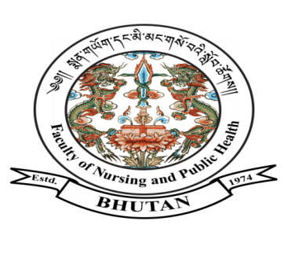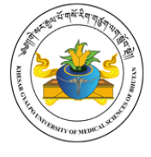

**FACULTY OF NURSING AND PUBLIC HEALTH**

**KHESAR GYALPO UNIVERSITY OF MEDICAL SCIENCES OF BHUTAN**

THIMPHU: BHUTAN

**Ref.No. FNPH/PLG/04/HRM/2022/2159 January 16, 2022**

**NOTIFICATION**

The Faculty of Nursing and Public Health (FNPH), KGUMSB is pleased to notify the shortlisted applicant for the post of core faculty from Department of Dentistry, JDWNRH. This is as per Vacancy Announcement letter no**. KGUMSB/HR/11/2022/944 dated January 13, 2023.**

|  |  |  |  |  |
| --- | --- | --- | --- | --- |
| **Sl. No** | **Name** | **CID** | **Department** | **Remarks** |
| 2. | Dr. Choki | 10404000534 | Dental Department, JDWNRH | Shortlisted |

Note:

1. The selection interview for the above shortlisted applicants shall be conducted **on January 23, 2023 at 3.00 PM** in the **Faculty Conference Hall, FNPH.**
2. The applicant should produce Original Course completion certificates and other relevant training certificates, for the purpose of verification of the documents.
3. The Position Level shall be fixed as per qualification and relevant work experience as per CoS-2018.

For any further queries, contact ADM/HR Officer- FNPH @ 02-322031/17638220 during office hours.

***Sd/-***

(Ms. Manikala Moktan)

**Offtg. Dean**