**

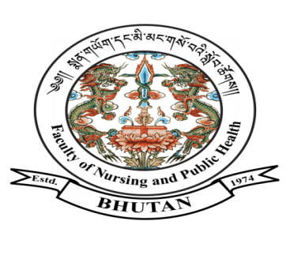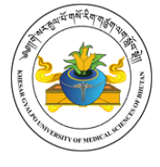

***FACULTY OF NURSING AND PUBLIC HEALTH***

**KHESAR GYALPO UNIVERSITY OF MEDICAL SCIENCES OF BHUTAN**

THIMPHU: BHUTAN

Ref No. FNPH/PLG/04/HRM/2023/2194 January 24, 2023

**Notification**

The Faculty of Nursing and Public Health, Khesar Gyalpo University of Medical Sciences of Bhutan is pleased to **announce the result of the selection interview held on January 23, 2023** for the post of core faculty (Department of Dentistry), Jigme Dorji Wangchuck National Referral Hospital, Thimphu as given below:

|  |  |  |  |  |  |
| --- | --- | --- | --- | --- | --- |
| **Sl. No** | **Name** | **CID** | **Department** | **Total Score**  **(100%)** | **Remarks** |
| 1. | Dr. Choki | 10404000534 | Department of Dentistry | **81.90%** | **Selected** |

**Note:**

1. The candidates will have 5 working days period with effect from the date of notification of the result for appeals related to the selection interview.
2. The selected candidates are required to report to the HR Section, KGUMSB on

**February 1, 2023**for appointment and further directives.

**Sd/-**

(Dr. Chencho Dorjee)

**Dean**